**Bygg- og anleggsteknikk Vg1 / Building and Construction**

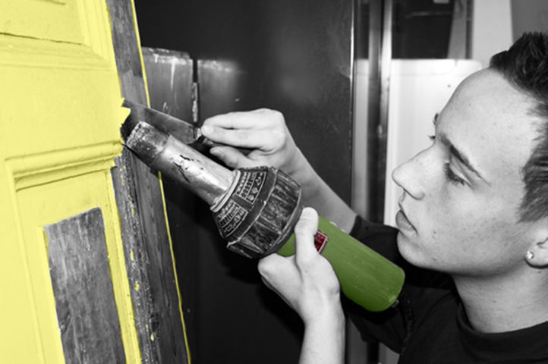  
   
*For students who wish to leave a visible mark by helping to create beautiful buildings, roads, bridges, outdoor areas, and facilities.*

This vocational programme includes subjects in building technology, climate, surface technology, energy, and environmental studies. Choosing this programme may lead to professions such as carpenter, plumber, bricklayer, concrete worker, painter, and landscape gardener.

Your vocational training will include the production, construction, renovation, and maintenance of buildings and facilities, along with associated technical installations. Strict requirements for quality and safety are set.

After Vg1 in Building and Construction, you can apply to Vg2 with us. At Stovner videregående skole, we offer specialisations for carpentry, surface technology, plumbing, and landscape gardening. After completing this programme, you can also choose Vg3 Supplementary Studies to qualify for higher education.

**Helse- og oppvekstfag Vg1 / Healthcare, Childhood and Youth Development**

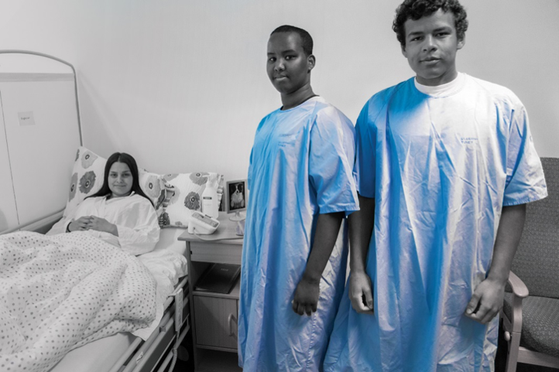

*For students who envision a future in the health and youth care sector, in kindergartens, nursing homes, or home care services, in a beauty salon, or perhaps at a pharmacy.*

Do you wish to gain a specialisation in health and youth care studies, foundational knowledge about the structure and function of the human body, preventive health work, nutrition, hygiene, first aid, and communication with others in all life stages and situations?

You can further your education after completing the first year with us. Our advanced programmes in Vg2 are in skin care and beauty, health care, and childhood and youth education and care.

**Naturbruk Vg1 / Agriculture, Fishing and Forestry**

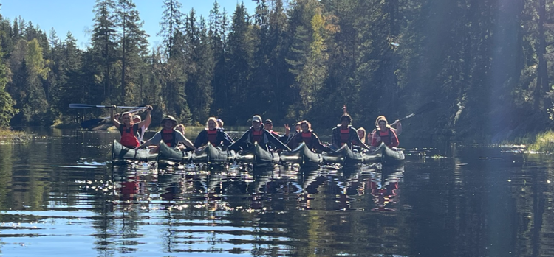  
*For students who want to learn more about animals, plants, urban agriculture, and outdoor life.*

This is the vocational programme for the student who loves nature and enjoys working with practical tasks. We spend a lot of time outdoors, have lessons in the classroom, or go on trips. In a regular class, there are up to 15 students, and you will have a classroom teacher who will follow your academic development closely. Throughout the year, the class becomes a close-knit group.

We often work at Øvre Fossum gård, where we engage in practical activities. The nearby riding centre also includes a visitor farm. Here, we can assist in caring for farm animals. Animal welfare, machinery, beekeeping, plants, entrepreneurship, and outdoor life are important themes throughout the school year. Our students also get a work placement experience during the school year.

**Teknologi- og industrifag Vg1 / Technical and Industrial Production**

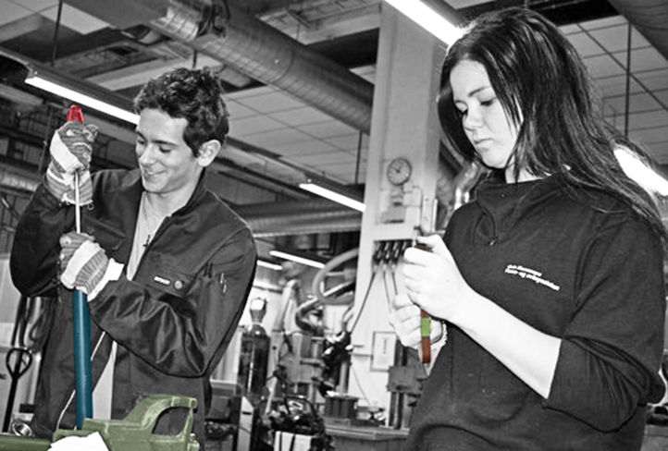

*For students who are interested in technology, mechanics, machines, and vehicles.*

This programme includes areas such as vehicles, industrial technology, transport and logistics, and maritime studies. If you join our programme in Technology and Industrial studies you will be qualified to works as a car mechanic, engine technician, industrial mechanic, logistics worker, automation technician, recycling operator, and locksmith.

We emphasise health safety and environment (HSE) in our programmes, as working according to procedures and drawings, as well as registration and documentation, is very important.

We offer Vehicle Studies in Vg2. After completing Vg2, you can also choose Vg3 Supplementary Studies to qualify for higher education.

**Rørlegger Vg2 / Plumbing**

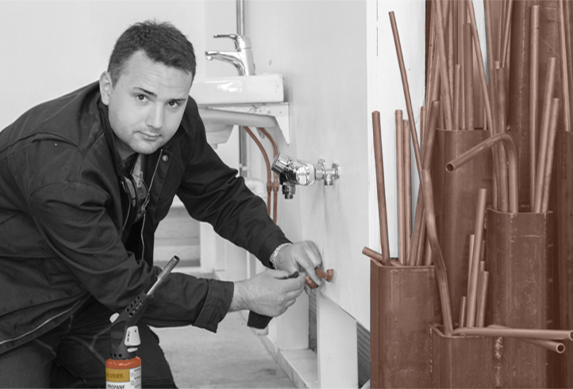

*For students who wish to work as a plumber.*

A plumber plans, installs, and repairs pipes and equipment for daily hygiene, heating and cooling systems, as well as specialised systems for fire extinguishing, compressed air, and gas installations. The plumber actively contributes to facilitating sensible energy use and protecting the environment.

The vocational programme in Plumbing builds on Building and Constriction Vg1.

After Vg2, you can do two years of apprenticeship with a final examination which will grant you a trade certificate as a skilled worker.

**Tømrer Vg2 / Carpentry**

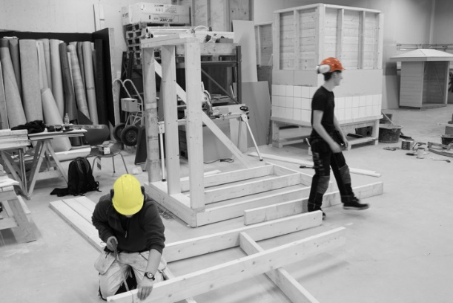

*For students interested in carpentry, contracting, or working in construction firms.*

Construction is a trade with long-standing traditions, which will provide extensive professional opportunities and specialisations.

The tasks of a carpenter, also known as a building carpenter, vary widely. Examples include the skilled construction of traditional wooden houses, rehabilitation of older buildings, erection of modular homes, repairs, and installation of light walls, doors, and windows in buildings.

You can qualify for our programme in Carpentry if you have completed the Vg1 vocational programme in Building and Construction. Following the completion of the carpentry programme, you can do two years of apprenticeship with a final examination which will grant you a trade certificate as a skilled worker.

**Barne- og ungdomsarbeiderfag Vg2 / Child Care and Youth Work**

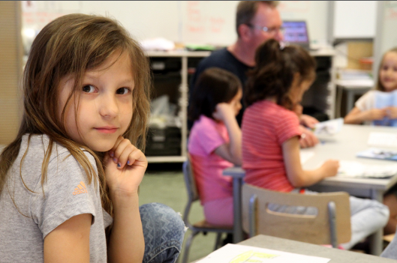

*For students who envision a future in child and youth work.*

Child and Youth Work may be the profession for you if you enjoy being with children and young people and find it exciting to follow their development.

This vocational programme aims to give future child and youth workers the skill set needed to facilitate activities, joy, and personal development for children and young people. Our focus is educating childcare and youth workers who are clear role models, acknowledge children’s individual needs, and are aware of the challenges faced by children and young people in a multicultural society.

The Child and Youth Worker programme is for students who wish to work with children and young people aged 0-18 years.

This education is specifically for those who want to obtain formal qualifications to pursue a trade certificate.

This is a popular programme, and the school arranges relevant internship placements in our local community.

**Helsearbeiderfag Vg2 / Health Work**

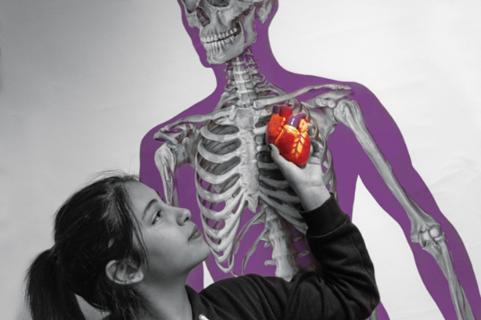  
 *For students who envision a future in the health and welfare sector.*

Do you wish to gain in-depth knowledge about the structure and function of the human body, preventive health work, nutrition, hygiene, first aid, and communication with others in all life phases and situations?

The school has a working collaboration with our local district, which provides us access to extensive internship placements.

**Kjøretøy Vg2 / Motor Vehicles**

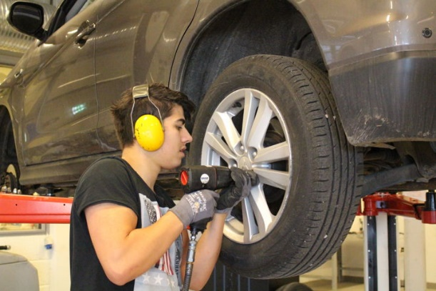

*For students interested in vehicle repair.*

Stovner videregående skole offers the Vg2 Motor Vehicles programme, which builds on the Vg1 programme in Technology and Industrial Production. After completing this vocational programme, you may go on to sign a contract of apprenticeship in automotive fields such as light vehicles, heavy vehicles, motorcycle repair, vehicle damage assessment, bodywork, motor mechanics, and wheel equipment.

Students gain fundamental knowledge about the structure and function of various vehicles, allowing them to specialise in different areas. Skilled workers in these fields must be able to repair and maintain various types of vehicles, utilising both older technologies and those based on newer innovations.

This programme emphasises the need for car mechanics who are skilled in programming and handling electronic systems.

**Anleggsgartner Vg2 / Landscaping Operator**

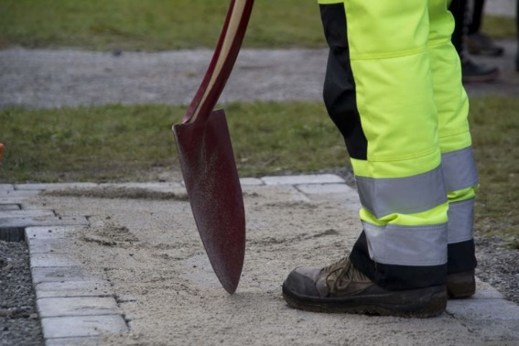

*The only landscape operator programme offered at upper secondary schools in Oslo.*

The landscape operator profession involves the construction, management, and maintenance of gardens, parks, recreational areas, and sports facilities. As a landscape operator, you will gain a good aesthetic and functional understanding of vegetation and materials. Landscape operators are needed to support green and sustainable urban development, especially considering the challenges we face with climate change. The school has a landscape operating facility and uses Øvre Fossum gård as a learning arena. We also arrange vocational placement for students with local companies.

You can qualify for this programme with a background in either Building and Construction Vg1 or Agriculture, Fishing and Forestry Vg1.

**Heste- og dyrefag Vg2 /** **Equestrian and Animal Studies**

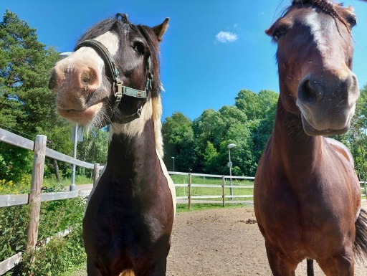

*For students who are very fond of animals.*

We are located next to a riding centre and petting farm with horses, pigs, ducks, chickens, goats, and rabbits. There are up to 15 students in one class, and you will have a classroom teacher who provides you with extra support. The classroom is located near our outdoor areas and school library. We also have access to Øvre Fossum gård.

**Landbruk og gartnernæring Vg2 / Agriculture and Horticulture**

*For students who enjoy plants, cultivation, beekeeping and being outdoors.*

We have a greenhouse, garden beds, beehives, an apple orchard, and a hydroponic growing room. Instruction will take place in these locations with practical as well as our regular classrooms. There are up to 15 students in one class, and you will have a main teacher who provides you with extra support. The classroom is located near our outdoor areas and school library. We also have access to Øvre Fossum gård.

**Overflateteknikk Vg2 / Surface Treatment Work**



*For students who want to pursue a career in the painting or floor-laying profession.*

Meet the high demand for skilled painters and floor layers in Norway by enrolling in the Surface Treatment Work programme at Stovner videregående skole. The Vg2 programme builds on Building and Construction and provides a foundation for a training contract in the painting profession, floor laying profession, or industrial painting profession.

Students gain fundamental knowledge about various surfaces to paint on, how to treat and maintain different surfaces, colour theory, wallpapering, refurbishing and installing new flooring, indoor painting, and outdoor painting, with a strong focus on health, environment, and safety.

**Hudpleie Vg2 / Skin Care**

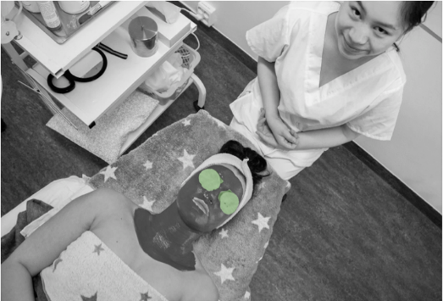

*For students who want to pursue a career in beauty and skincare.*

Skin Care is a profession with many opportunities and is part of an industry that is constantly evolving.

The work of a skincare therapist requires precision, creativity, and aesthetic sense. You will work closely with people, so it is essential that you enjoy communicating and can create a sense of security and trust. As a skincare therapist, you need to be service-oriented and have a customer-focused approach.

The beauty salon at Stovner videregående skole offers treatments to the public. This is a popular service within the local community and provides highly relevant practical experience for our students. Students manage the school’s salon, have regular salon days each week, and collaborate closely with local businesses and various skincare-related companies. The education aligns with the demands of the industry, and our teachers support students in their vocational and school life.

**Hudterapi Vg3 / Skin Therapy**

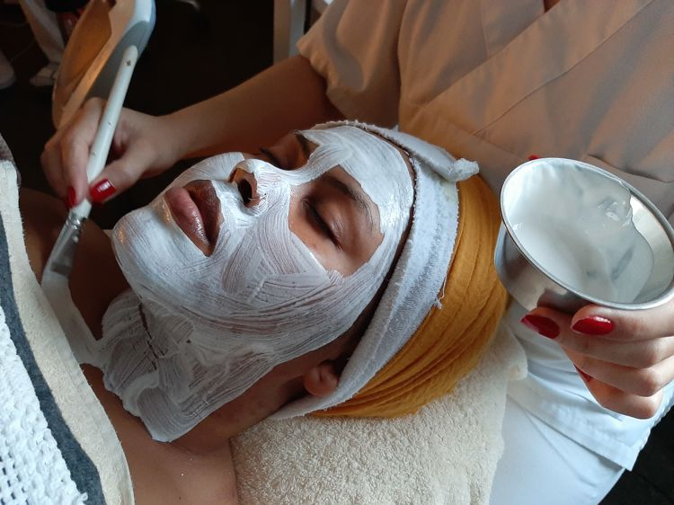

*For students who want to pursue a career in beauty and skincare.*

Skin Care is a profession with many opportunities and is part of an industry that is constantly evolving. After completing the third-year programme you can work as a skincare therapist.

The work of a skincare therapist requires precision, creativity, and aesthetic sense. You will work closely with people, so it is essential that you enjoy communicating and can create a sense of security and trust. As a skincare therapist, you need to be service-oriented and have a customer-focused approach.

The beauty salon at Stovner videregående skole offers treatments to the public. This is a popular service within the local community and provides highly relevant practical experience for our students. Students manage the school’s salon, have regular salon days each week, and collaborate closely with local businesses and various skincare-related companies. The education aligns with the demands of the industry, and our teachers support students in their vocational and school life.