**Studiespesialisering Vg1 / General Studies**

*For students who want to continue to higher education.*

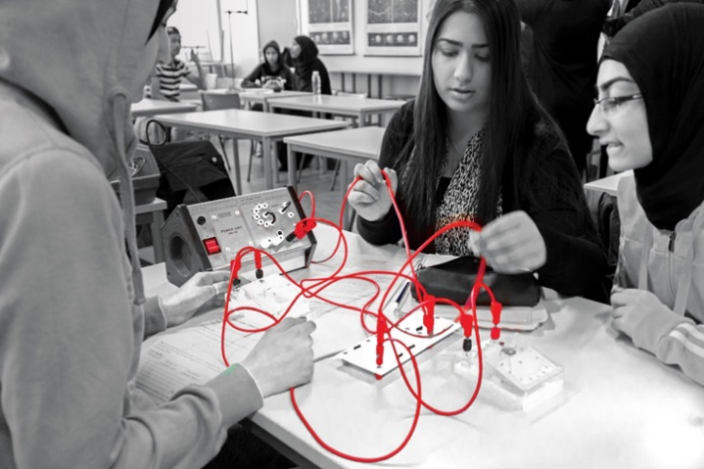

Our general studies specialisation will give you the tools to master higher education and learn the skills needed in our knowledge-based society. The first-year programme gives students an introduction to the humanities, social and natural sciences and gives you a foundation for further studies.

You should be interested in working with theoretical subjects, be cooperative, structured, and self-disciplined. You should also have an interest in writing or mathematics and be engaged in cultural and social issues.

**Studiespesialisering Vg2/Vg3 – Språk, samfunnsfag og økonomi / General studies -Languages, Social Sciences and Economics**



*A completed diploma in Languages, Social Sciences and Economics will give you access to a vast majority of higher education programmes in Norway and abroad.*

Would you like to become a lawyer, legal professional, psychologist, nurse, radiographer, civil economist, manager, estate agent, journalist, teacher, run your own business, or work in sales and marketing? Or perhaps you’re not quite sure what you want to study yet? If so, languages, social studies, and economics is the right programme area for you.

**Studiespesialisering Vg2/Vg3 – Realfag /**

**General studies - Natural Science and Mathematics**

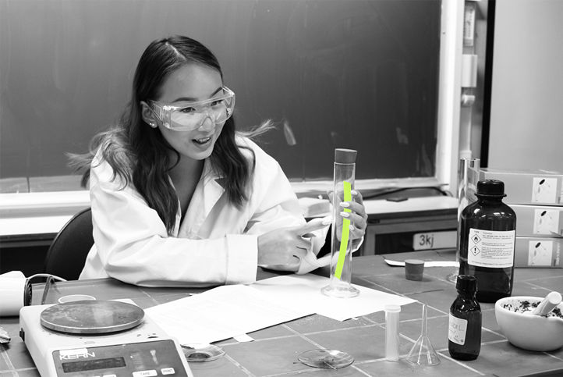

*A completed diploma in Natural Science and Mathematics will prepare you for further studies in STEM in Norway and abroad.*

Are you good at mathematics and science and would like to become a doctor, architect, or engineer? Are you keen to discover the researcher within you and uncover phenomena you didn’t know existed? Do you want to challenge your curiosity and exploring spirit? If so, perhaps the sciences are the right choice for you.

**Naturbruk studieforberedende Vg3/**

**General Studies in Fishing and Forestry**

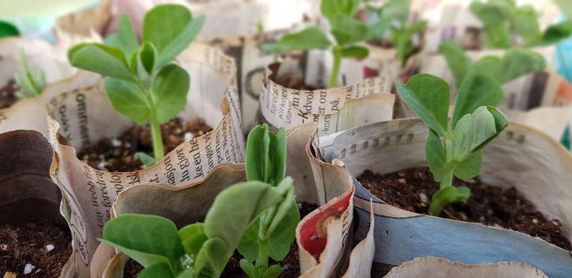

*For students who want the opportunity to continue further studies after completing Agriculture, Fishing and Forestry Vg2.*

After completing Agriculture, Fishing and Forestry Vg2, you can opt for the general studies programme in Fishing and Forestry. While Agriculture, Fishing and Forestry is a vocational subject, following this stream will qualify you for further studies at an institute of higher learning.  The programme is largely characterised by theoretical instruction.

**Påbygging til generell studiekompetanse for yrkesfaglige utdanningsprogram /**

**Supplementary programme for general university and college admissions certification**

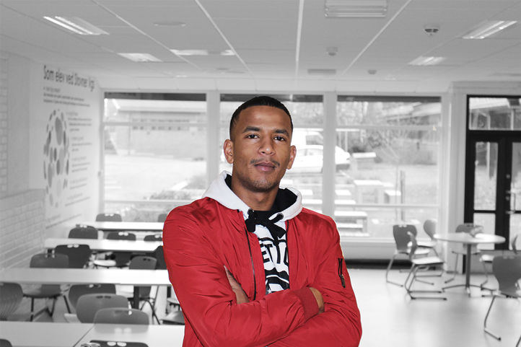

*For students who want the opportunity to continue with higher education after completing vocational studies.*

After completing your vocational studies, you can opt for the supplementary programme for general university and college admissions certification. This will qualify you for further studies at an institute of higher learning.  The programme is largely characterised by theoretical instruction.